|  |  |
| --- | --- |
| Team ID | TM001810 |
| Department Name | Science & Technology Department |
| Problem ID | PID112 |
| Problem Statement | Gujarat Directory |
| Team Leader Details | Name: Koladiya Hardik Madhubhai  Email: [200120107117@git.org.in](mailto:200120107117@git.org.in)  Contact no.: 9081709946 |
| Faculty Details | Name: Drashti S. Darji  Email: [drashti.darji@git.org.in](mailto:drashti.darji@git.org.in)  Contact no.: 8460205011 |

**Synopsis Abstract** : This website namely "Gujarat Directory" consist of all the Governmental departments and their sub-organizations in an organized way, where one can easily find a particular portal for a particular department and its sub organizations, along with information's like contact and their purpose and role.

**Literature Review/Existing Innovation-technology to address related to your problem :** Whenever a citizen wants to know about various information of different departments and its relevant sub organization they have to visit their website individually. Structure and GUI of website of different departments are also varied. So, the citizen can’t be able to retrieve relevant information easily. It’s also difficult for the people to find the official portal of these departments when needed. Also, many citizens are unaware about the role and sub-organizations these departments. This problem can be solved by making such a platform that shows all departments of Government and also its sub-organizations at one place.

**What would be your approach to solve the problem** : Our approach towards problem is that Firstly, we will start gathering information about all the departments which are there in Gujarat along with their sub-organizations. We will collect some basic information about these organizations like their purpose etc., along with their logos and moto’s. Then we will start making website by taking information and working on the appearance of the website, how it will look, how it will display the information's which can easily be understood by the users. After that we will start building the portal using HTML and CSS. Then we will try to optimize it so that it becomes easy to access and easy to understand.

**Road map/Flow diagram to develop final solution (1)** :

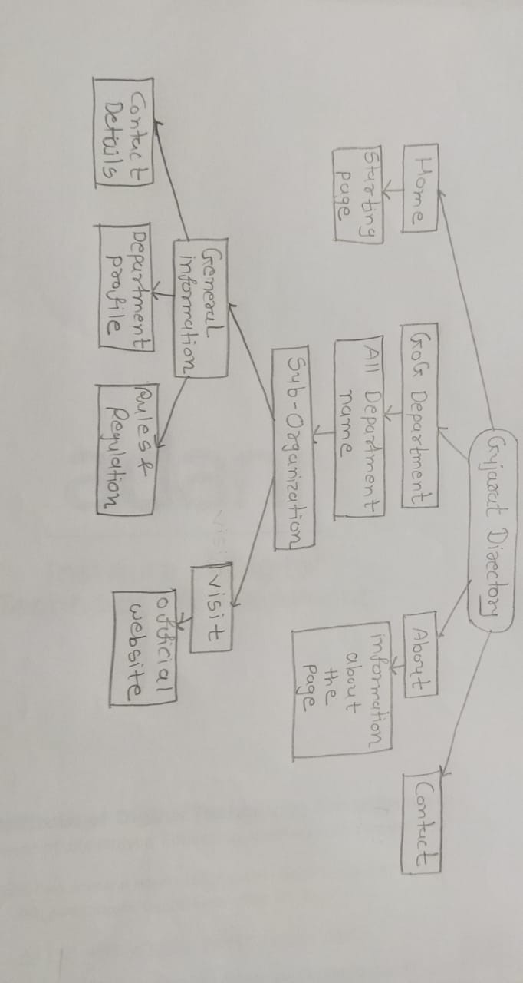

**Road map/Flow diagram to develop final solution (2)** :

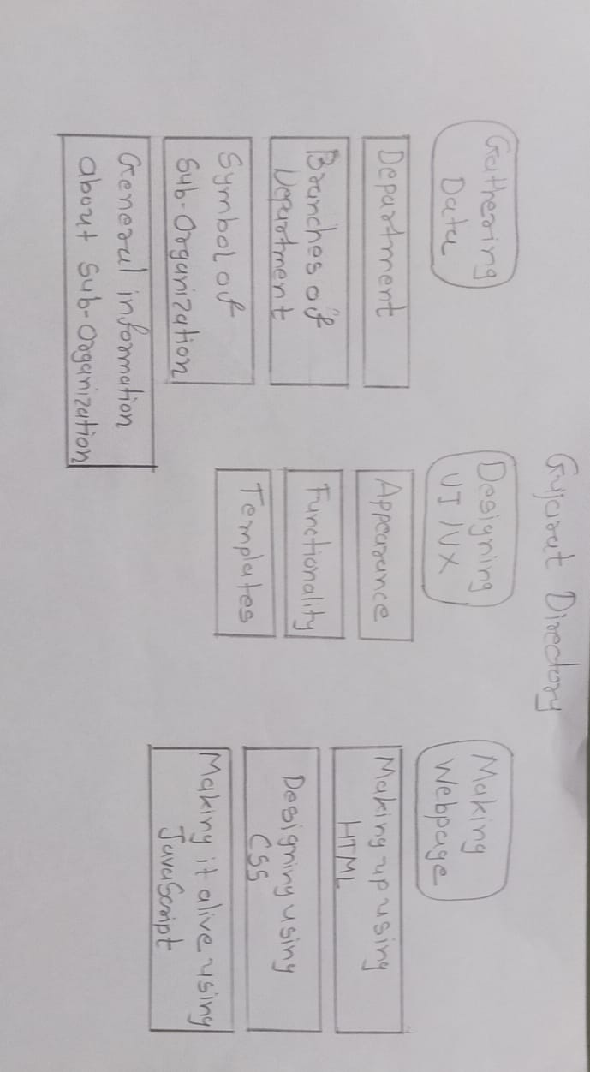

**Tools and technologies to be used to solve the problem** :

We will use language like HTML, CSS and JavaScript to build this website. We will use HTML for Markup, to develop code , CSS for Appearance, making website more beautiful and placing all details at right place.

We will use Visual Studio Code and Adobe Dreamweaver as an Editor (for Coding and Compiling). Canva (online editing website) for making creating icons.

YouTube for learning tricks for Web development, Customization and Optimization. We will use Google for collecting some required information and data for the website development.

**Challenges/Risk in implementing your Final prototype** : Making a "Responsive Website" is challenge in itself. Collecting data and information, and organizing them in an understandable way is also one of the major challenges in this project. Learning some new tricks and methodology for the developing website and designing UI/UX is the biggest challenge as it will define the look of the website. It also took the most of the time. One challenge was that, building a website design on drawing pages is easy as compared to implementing that design on an actual working website, on have to smartly make use of CSS to achieve the desired result. There are many challenges for making this website that requires much of data and information related to government.

**Possible outcome of your work** : Website that displays all departments of government After Clicking department there should be sub organization On visiting Sub organization/ Department citizen should be able to access some basic information (including contact details) and schemes of that department/organization. This will help citizens a lot, as all the data or information about the Gujarat's governmental department and its sub-organization will be on same webpage. Now they don't have to search for the organization via name on google again and again. Citizens can simply access this information and navigate through it. Many citizens are unaware of the fact that, "This organization had their own personal website". This will help them to educate about the Governmental sector and how they can be used for the benefit.

**Work done till date** : Till now, I have gathered information about the Gujarat Government departments and their Sub services and organization. Now, we are working on the developing the web page, appearance and setting how it will work and how it will represent information on an website called Visily (It’s an online service, which helps in creating UI/UX for the applications and websites for free). We are searching for Logo’s for this departments to used it for better user experience, we have started collecting them and organizing them with proper naming so that they can be attached easily to the webpage.

**Image/Screenshot of Solution (1)** :

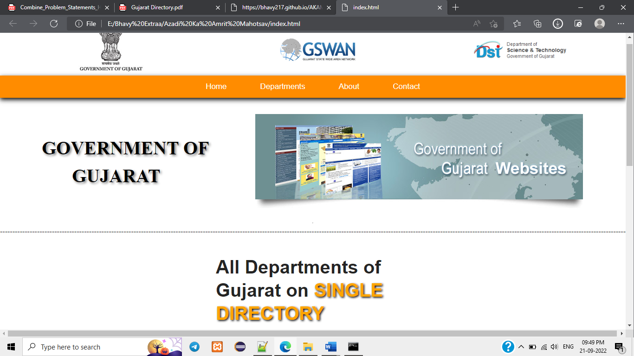

**Image/Screenshot of Solution (2)** :

